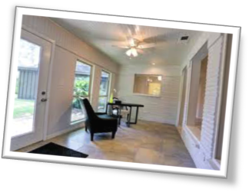
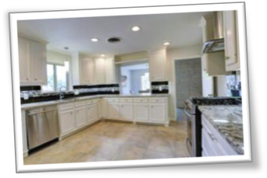
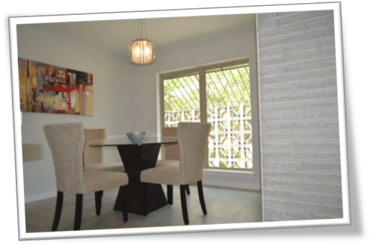
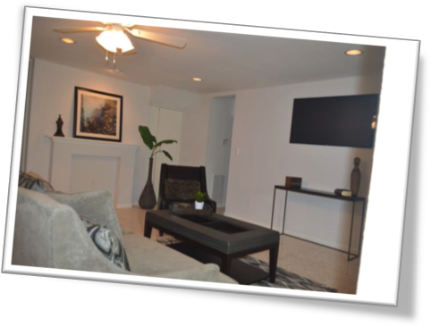
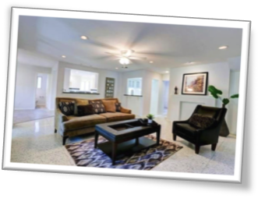
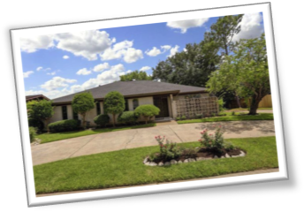
Helping Buyers Find A Home
Mid-Century Design With 21st Century Appeal
Contemporary and Urban Chic

Real Estate Auctions
5759 Ariel St, Houston, TX.77096
Have you ever attended an auction?
Have you heard the Auctioneer talk fast and take bids from the audience?
Did you know that Real Estate Auctions happen everyday all over the world?
As a Realtor & Auctioneer I strive to service every need my client’s may have. From personal property to real property, I offer a turnkey advantage that liquidates assets into cash and moves inventory with efficiency.
For Home Buyers~Auctions provide a unique opportunity to bid for their dream home in person, online or via sealed bid. This often results in the buyer obtaining an excellent piece of property and/or home under market value. Of course, this no guarantee, the more desirable the home the more competition and higher the bid amounts. Depending on your market & location properties may even exceed market value.

www.BoldBids.com

www.MyRealEstateExpert.com

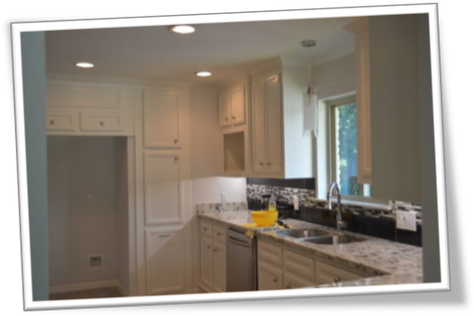
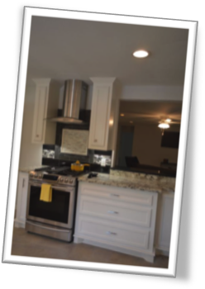
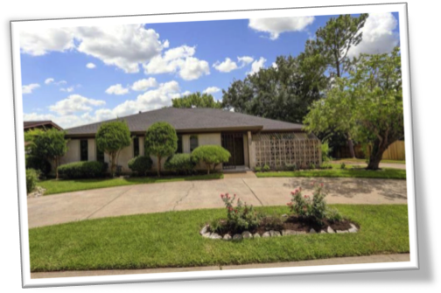


What To Expect
Auctions are designed to be quick & efficient. Most real estate auctions close in less than 45 days.
Pre-Approval is a must for those who are going to have a mortgage on the property.
Cash buyers can close within 7-10 days.

Buyer’ Premium
A Buyer’s Premium is charged on top of the winning bid. Real Estate Auctions typically have a sliding scale that can range from 3%-15% depending on the type of property. This is the where the Realtor (if used) will earn their commission.

Auction Day
Show up approximately 1 hour prior to the start of the auction. A $2500 deposit with an approval letter from the Mortgage Company or proof of cash funds (Bank Letter) up to $475,000 is required to bid. The auction starts promptly at 2:00pm. The auctioneer will open up the bidding and the property will sell to the highest bidder.

Colette Clift Mayers, Realtor Auctioneer
I’ve performed real estate auctions on behalf of banks, mortgage companies and Trustees across the U.S. I love the auction method of marketing and the unique opportunities it provides to buyers. Please give me call or send me an email. I’m happy to assist and answer any questions you may have.
See you on auction day!

